BUILDING/BLOCK – ALL CAPITAL LETTERS, BOLD, CALIBRI, 11
HEAD1 – ALL CAPITAL LETTERS, BOLD, UNDERLINE, CALIBRI, 11
Head2 – BOLD, UNDERLINE, CALIBRI, 11
Head3 – BOLD, CALIBRI, 11
Head4 – CALIBRI, 11 (Note: Optional), UNDERLINE
Items with quantities including notes – ITALIC, CALIBRI, 11
OMISSION and ADDITION – ALL CAPITAL LETTERS, BOLD, CALIBRI, 11
(Note: With noidc in unit column)

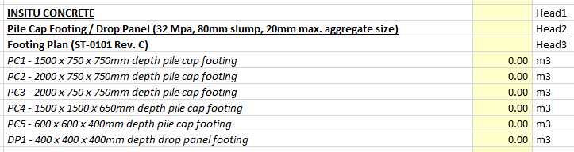
Sample:

